Object-based permissions – Lucas Haas





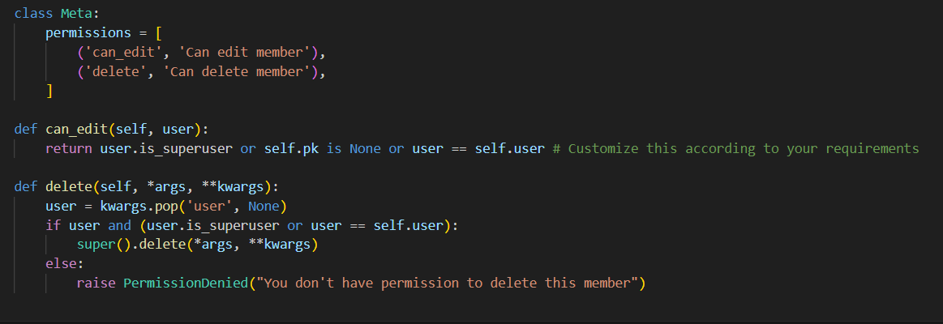

From django’s auth models, we can use the already defined user and pass it as a model one to one field. From there we define a meta class with permission strings that point to the functions we want to handle the logic for permission. We grab the current user and return to check logic behind if someone is a user tied to that member class, in my case.

We can then call can_edit and delete to perform the checks for permissions.

[Django Tutorial Part 8: User authentication and permissions - Learn web development | MDN (mozilla.org)](https://developer.mozilla.org/en-US/docs/Learn/Server-side/Django/Authentication)